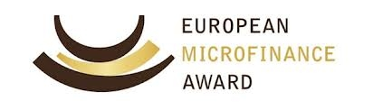

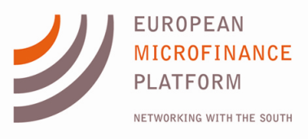
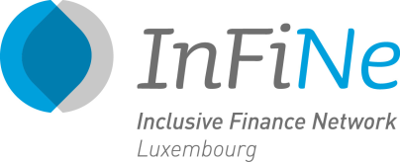
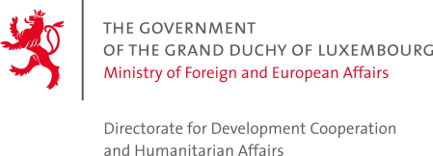
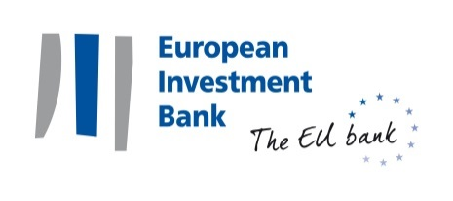

Luxembourg, 13 November 2014

5th European Microfinance Award and new Memorandum of Understanding between the Luxembourg Government and the EIB

Kompanion Financial Group wins the 5th European Microfinance Award for Microfinance and the Environment
- The Government of Luxembourg and the EIB sign an MoU to continue supporting together microfinance activities in ACP countries

On 13 November, for the occasion of European Microfinance Week, Her Royal Highness Maria Teresa, Grand Duchess of Luxembourg presented Kompanion with the 5th European Microfinance Award, for its commitment to both microfinance and environmental sustainability.

The European Microfinance Award was launched in 2005 by the Luxembourg Ministry of Foreign and European Affairs – Directorate for Development Cooperation and Humanitarian Affairs. It is jointly organised by Luxembourg’s Directorate for Development Cooperation, the European Microfinance Platform (e-MFP), and the Inclusive Finance Network Luxembourg (InFiNe.lu), in cooperation with the European Investment Bank (EIB).

For this year's award, 26 applications from 19 countries were received. The Luxembourg Minister for Development Cooperation and Humanitarian Affairs, Mr. Romain Schneider said "We offer this prize to stimulate innovation in microfinance, and are pleased that this goal remains as important as ever. Environmental changes disproportionately affect the poorest people in developing countries, and the examples of this year’s finalists as well as so many other applicants demonstrate that financial inclusion and environmental sustainability can go hand-in-hand. I expect that their examples will promote greater focus on the environment across the sector."

Kompanion Financial Group received the EUR 100,000 prize from the Luxembourg Ministry of Foreign and European Affairs – Directorate for Development Cooperation and Humanitarian Affairs in a ceremony hosted by the EIB. According to Olesia Paukova, Director Development Services, Kompanion Financial Group, “With the prize money we plan to develop a ‘mobile classroom’ to reach the herders in remote pasture lands and provide trainings in more villages across Kyrgyzstan. We will also develop video materials to be used in public schools in remote areas. These materials will connect students in those areas with our livestock management experts who will present the best pasture land management practices. This will increase our outreach even further.”

Prior to the ceremony, Minister for Finance Pierre Gramegna, Minister Schneider and EIB President Werner Hoyer, signed a Memorandum of Understanding (MoU) between the Luxembourg Government and the EIB. Under this agreement, the fourth of its kind between the Bank and Luxembourg, EUR 3.6 million of grants will be provided to support microfinance institutions in African, Caribbean and Pacific countries, including those hit by the Ebola crisis.
Under the three previous MoUs, more than EUR 8 million of grant funding was provided to 25 microfinance projects in 17 countries.
President Werner Hoyer also paid tribute, saying that “Luxembourg has become a recognised centre in the field of inclusive finance, and the Government has been a reliable and strong partner of the EIB since the beginning. The new MoU will allow us to continue promoting responsible microfinance as a powerful tool in financial inclusion and sustainable economic development.”

European Microfinance Week - sharing experiences and providing opportunities

The award ceremony itself was held in the framework of the European Microfinance Week, which in addition to featuring the winner and the two other finalists, proposed several panels exploring opportunities for microfinance institutions to simultaneously serve the poor, while also contributing to environmental sustainability.

Speakers from all over the world, including the three award finalists explored opportunities for using microfinance to increase access to green energy and to promote, among others, ecosystems protection, biodiversity conservation and adaptation to climate change. They also discussed the methodology for assessing and reporting on environmental performance in a way that can encourage social investors and others to direct their funds to institutions delivering on triple bottom line objectives.

In the face of increasing challenges posed by climate change, environmental sustainability is not just a concern for social investors. Each of the three finalists has demonstrated how microfinance can directly contribute to improving the lives of microfinance clients themselves:

- ESAF Microfinance and Investments, India: many of the clients of this rural lender have no reliable access to energy, clean water, and often deal with dangerous levels of indoor air pollution due to the use of inefficient cook stoves. In response, ESAF’s Clean Energy for the Poor initiative is enabling its clients to purchase solar energy solutions, efficient cook stoves, and water filters.

- Kompanion Financial Group, Kyrgyzstan: with the country’s lands facing massive levels of environmental degradation due to decades of poor farming practices and land mismanagement, Kompanion’s Pasture Land Management Training Initiative, provides a specialized "Credit for Conservation" loan linked to a training program for livestock farmers, which introduces sustainable land management practices and helps restore previously degraded lands.

- XacBank LLC, Mongolia: with Mongolia’s capital Ulaan Baatar ranking among the most polluted cities in the world, XacBank has responded with its Eco Product Program, under which it has facilitated the purchase of over 150,000 energy efficient heating and insulation products to poor ger district households in Ulaanbaatar (gers are traditional nomadic yurts that are costly and highly polluting to heat with traditional coal stoves.)

Press contacts:

European Microfinance Platform:
Niamh Watters, nwatters@e-mfp.eu, +352 26271356

European Investment Bank:
Sabine Parisse, s.parisse@eib.org, +352-4379-83340, +352 621 459 159
Website: www.eib.org/press - Press Office: +352 4379 21000 – press@eib.org

Ministry of Foreign Affairs and European Affairs, Directorate for Development Cooperation and Humanitarian Affairs:
Alexandra Allen, alexandra.allen@mae.etat.lu, +352 2478-2480

Ministry of Finance
Lucien Michels, Lucien.michels@fi.etat.lu, +352 2478-2698

