MEMBERSHIP APPLICATION FORM

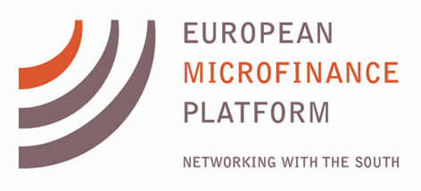

1 - Organisation – general information

1.1 - About your organisation:

Full name
Short name
Country (headquarters)
Foundation year
Total number of staff in organisation
Total number of staff working on microfinance (full-time equivalent)
Address
Phone
Fax
Email
Website

1.2 - About your organisation’s contact person:

Name
Position
Phone
Skype address
Fax
Email

2 - organisation – Descriptive information

2. 1- Type of organisation
Please tick:
Non-Profit
Profit

Please tick which type best describes your organization:

Consultants and support service providers (such as consultancy firms and individuals, law firms, raters, IT companies)
Investors (microfinance investment funds, fund management companies, banks and other financial institutions that invest in microfinance and financial inclusion)
Multilateral and national development agencies (public development agencies and development finance institutions)
NGOs (European national networks, associations, platforms and other NGOs)
Researchers (research institutes, universities, individual researchers and academics, and students working in areas related to microfinance or financial inclusion)
Others (please specify): __________________________________________________

2.2 – Institutional budget:
Does your institution have an annual institutional budget of more than € 1 million?
Please tick:

Yes
No

2.3 - Mission and main objectives (as per business plan):
Please provide mission and main objectives according to your organization’s business plan) (max 200 words)

2.4 - Please list the networks of which your organisation is a member

European Microfinance Network: ___________________________________________
MFC: _________________________________________________________________
Others: _______________________________________________________________

3 - Microfinance activities – Specific Information

3.1- Size of microfinance activities:
Please indicate with a tick, the percentage of microfinance activities (compared to the overall activities of your organisation) or, if your organisation is a network, the percentage of microfinance members (as a percentage of the total members of your network).

Between 0 and 20%
Between 20 and 50%
Between 50% and 70%
Between 70% and 100%
100%

3.2- Countries/Regions of Intervention:
Please tick in which regions your organization is active, and provide a list of the countries where your organization is active per region. If your organization has programmes open to organizations from all regions, please tick “Programmes open to all regions”

Africa
Countries: ____________________________________________________________

Asia
Countries: ___________________________________________________________

Europe
Countries: ___________________________________________________________

North America
Countries: ___________________________________________________________

South America
Countries: ___________________________________________________________

Oceania
Countries: ___________________________________________________________

Programmes open to all regions.

3.3 - Main areas of intervention
Please describe your organisation and its activities in the field of microfinance and financial inclusion:

3.4 - Plans for the coming years
Please indicate any innovations in your microfinance program planned for the coming years

